WGRF 2020
SCOTTSDALE, AZ
PART DOS!!!

23-25, 2020

WHERE IS WESTWORLD
And
SCOTTSDALE, AZ?
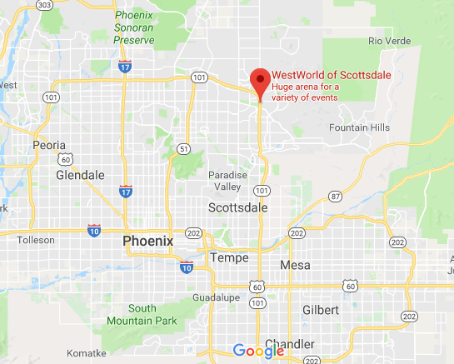

ARIZONA IS CENTRALLY LOCATED
FOR MANY HORSE CONTESTANTS

After WGRF 2019 You’ll Be Familiar With the

EQUIDOME

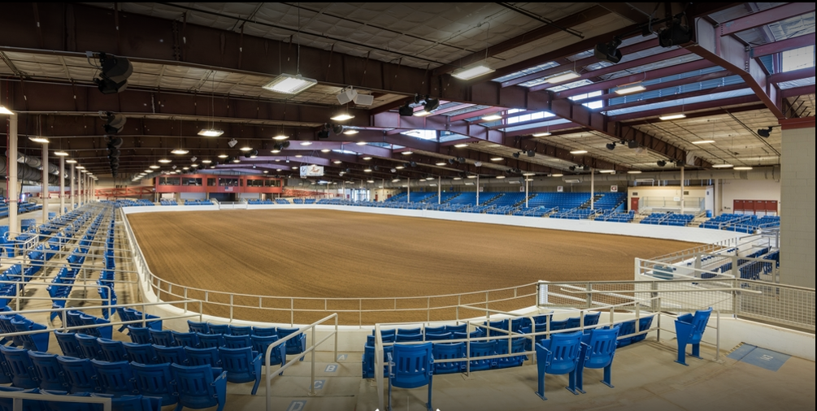

- An Indoor Arena
- That’s Climate Controlled
- Has 3,400 Permanent Seats
- With a Sunken Arena
- 120,000 Square Feet of Space
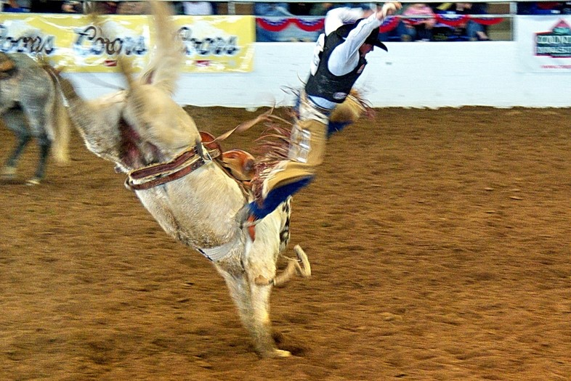
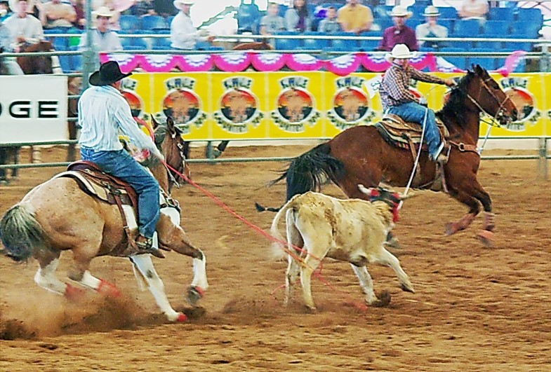

And Familiar with
WESTWORLD

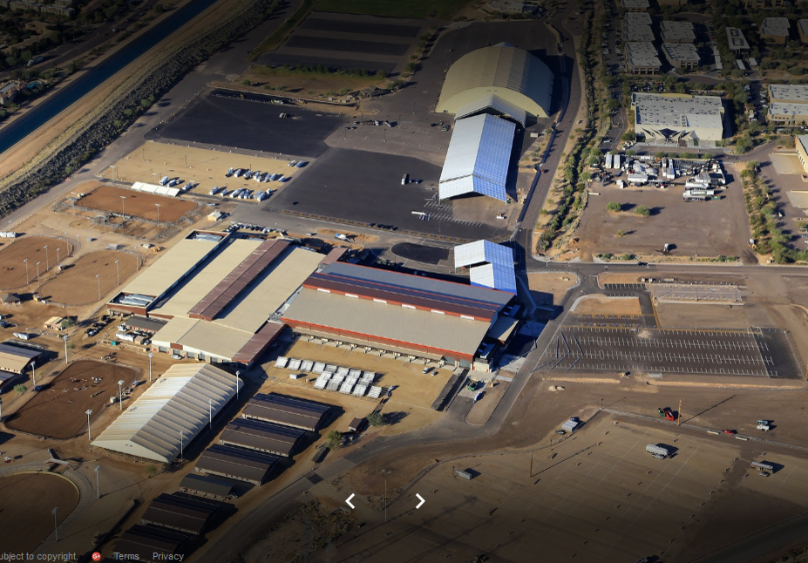

WESTWORLD:
- Located on 386 Acres at the Base Of McDowell Mountain
- Has 8 Outdoor Arena’s
- Permanent Premium Barn Facilities
- Over 395 Permanent RV Spaces Around the Arena With Electrical (Mix of 30amp and 50amp) and Water Hookups
- Dump Station on Site.

Cost is always an issue.

- We Qualify for $15,500 Grant money from the City of Scottsdale

- Category #1-Attendance $5,000
- Category #2-Event Days $5,000
- Category #3-Years in Scottsdale $2,000
- Category #4-Seasonality $1,000
- Category #5-Website Update $2,500
- TOTAL IN GRANTS $15,500

HOW IT ALL WILL BREAK DOWN FINANCIALLY

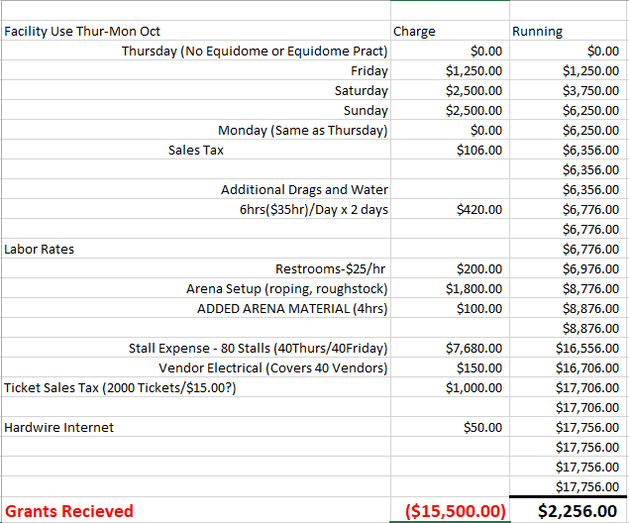

NET ARENA AND RELATED COST TO IGRA $2,256.00

